Ashington and District u3a
Registered Charity no: 1177454
Learn, Laugh, Live

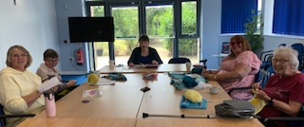
Free Social Event

Anyone who is retired or not in full – time employment is
invited to join us on:
Thursday 10th September from 1pm

Free Entry
Free Raffle ticket for a bottle raffle
Free Tea and Coffee with cake and biscuits

Find us at:
Trinity Church Hall,
Station Road,
Ashington
Further Information find us on facebook
Ashington & district official u3a

